Asthma Canada’s resources are available free of charge to residents of Canada.
Our resources are also available for download at www.asthma.ca.

Shipping/Contact Information:
Full Name | Title/Department
Organization
Address
City | Province | Postal Code
Email | Phone #
Website: | PO Number for Shipping Invoice (if applicable)

□ Please sign me up as an Asthma Canada Member Alliance (ACMA) member to receive our e-newsletter
□ Please sign me up as an Asthma Health Centre:
Your organization will be listed on the website and will receive new resource samples

Brochures, DVDs and Posters: Quantity Requested
Please Note: If you require a large order (20 or more copies of any single resource), or if you order for an organization, we will invoice you the shipping charges.
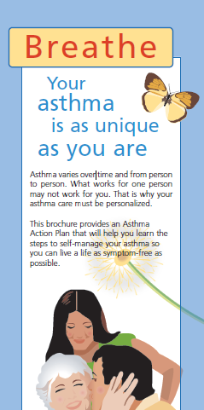

Breathe – Your Asthma is as Unique as You Are English French
Includes tips on self-management and a fillable
Asthma Action Plan

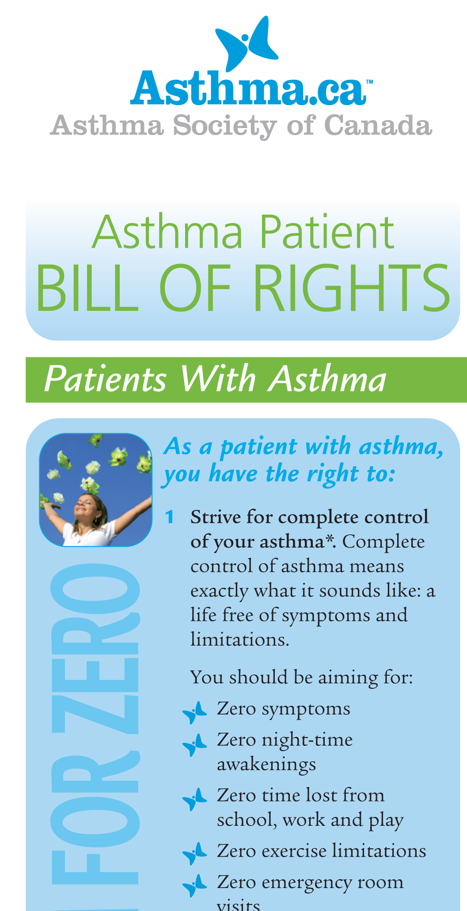
Asthma Patient Bill of Rights

- Brochure English French

- Poster English French
p


September Peak English
Sara’s ready for school

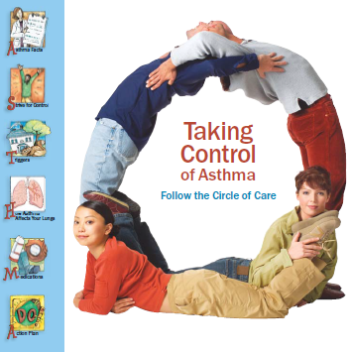
Taking Control of Asthma English French
Following the Circle of Care

Booklets |  |  | Quantity Requested
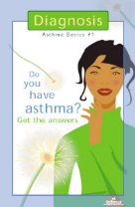  x | Breathe Easy™ #1 – Diagnosis  Discusses what asthma is, the diagnosis and testing, and answers common questions about asthma. It includes a checklist of questions you can consider asking healthcare professionals. |  |  | English |  | French
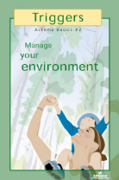    x | Breathe Easy™ #2 – Triggers  Discusses the common allergic and non-allergic triggers and steps that can be taken to control your asthma. It includes a checklist to use when planning changes to the home environment and a sample symptom diary. |  |  | English |  | French
 | Breathe Easy™ #3 – Medication  Discusses the common asthma medications and their side effects. Also highlights the various inhalers available and how to use them. Includes an Asthma Action Plan. |  |  | English |  | French
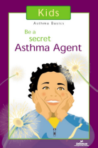  . | Breathe Easy™ #4 – Allergies  Explains the connection between asthma and respiratory allergies as well as ways to treat and manage respiratory allergies and minimize exposure. |  |  | English |  | French
  . | Self-Advocacy Guide  A handbook which will help guide you through complex healthcare systems and learn about people who can help you control your asthma. |  |  | English
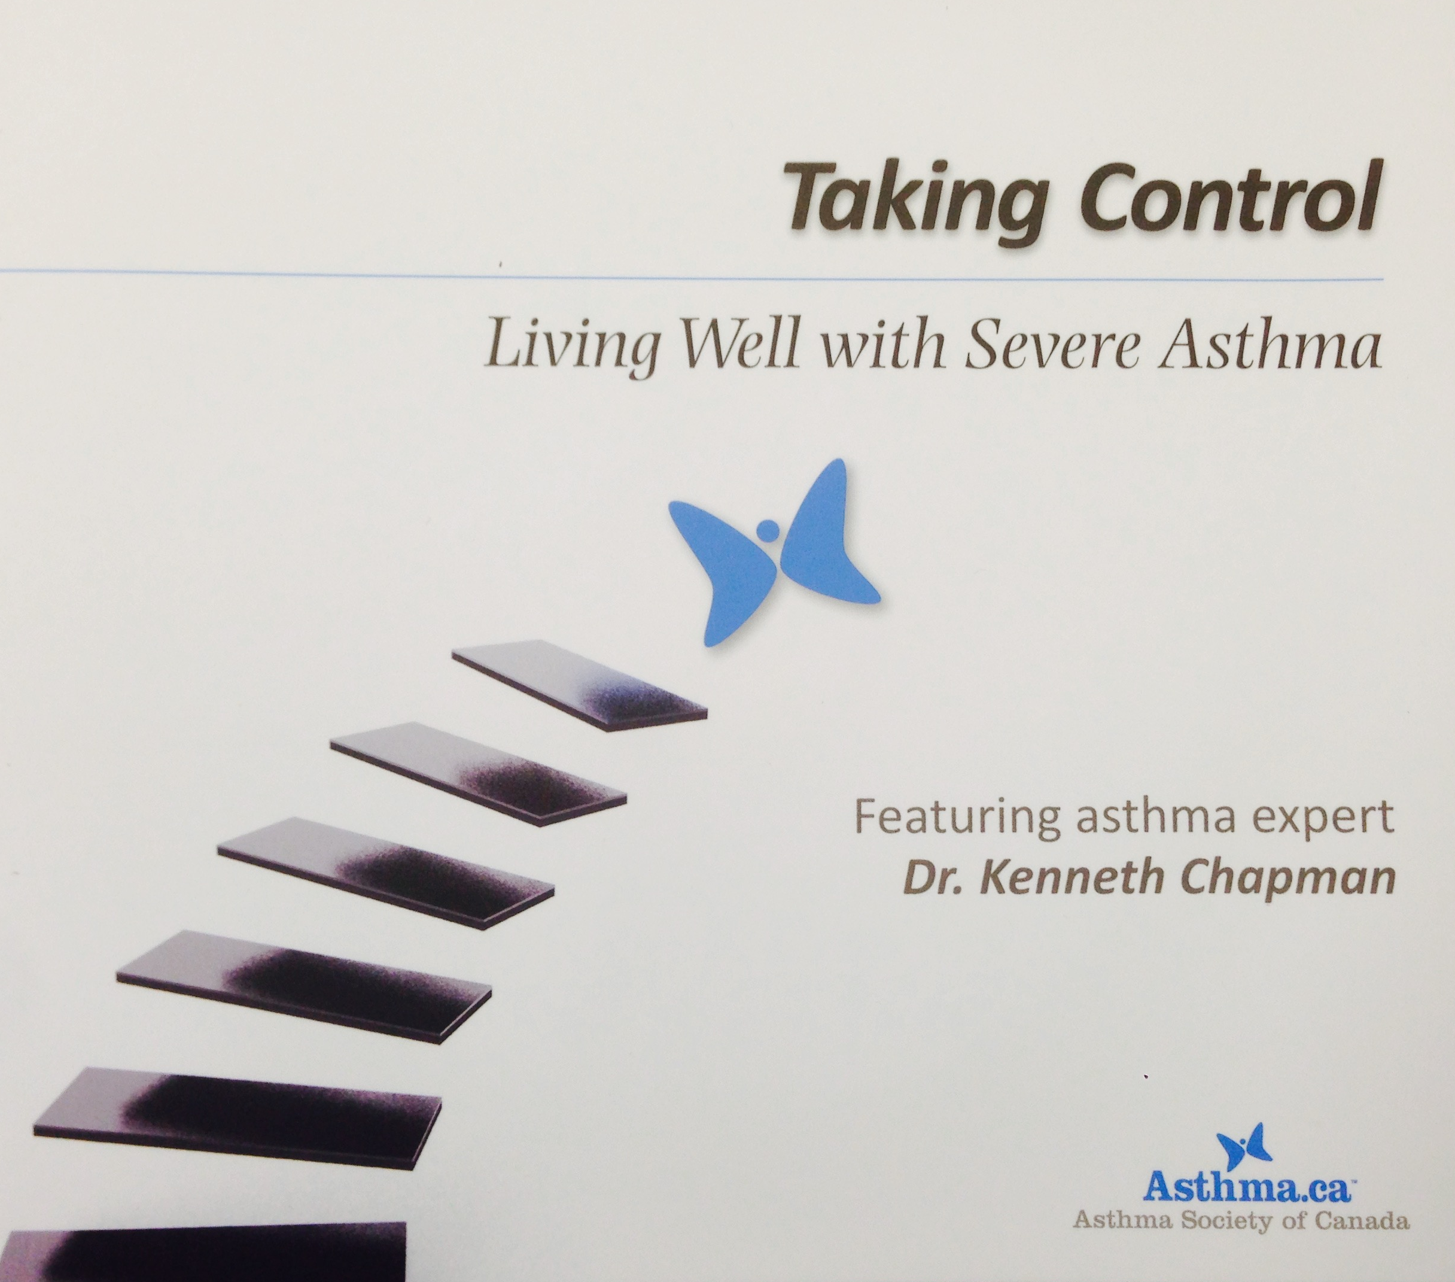 | Taking Control CD  Living Well with Severe Asthma |  |  | English |  | French
The following item is available for a Canada Post shipping charge – we can invoice you with the order or feel free to contact us for more details.
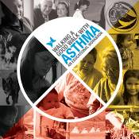  . | Walking A Good Walk with Asthma  Discusses the common allergic and non-allergic triggers and steps that can be taken to control your asthma. This workbook has been designed for the First Nations community members. |  |  | English
Thank you!
Return your completed form to:
mail: | Asthma Canada  124 Merton Street, Suite 401  Toronto, ON M4S 2Z2 | email: | info@asthma.ca
mail: |  | fax: | 416-787-5807

